Final Year Project (KIE4002)

Progress Report 1

**Automated Surface-based Intraoperative Registration for Brain Tumor Resection Using Machine Learning**

by

**Abdolroauf Rahmani**

**KIE170720**

Supervisor :

Prof. Mahmoud Moghavvemi

Department of Electrical Engineering

Faculty of Engineering

University of Malaya

2020

**Table of Contents**

​ Introduction (REFER TO THE GUIDE FOR MORE DETAILS) 3

​ General 3

​ Medical Profession 4

​ Visualization/rendering components 4

​ Frameworks 4

​ *Files/Objects/Protocols* 6

​ Motivation (Link Background to problem statement) 8

​ Research Methodology (Before this I need a problem and initial solution) 9

​ Reproducible Research 9

​ Work Done So Far 12

​ Next Semester Plans 12

​ References 12

​ Appendices 13

​ Proposal 13

# Introduction (REFER TO THE GUIDE FOR MORE DETAILS)

Introduction – background of your research topic and give the problem statement.

General

1. What is image registration?
   1. Compare it to similar techniques like alignments
2. What are different iterative methods used for image registration?
   1. Go through the technical details of hows...
3. What is the difference between standard registration and machine learning registration?
4. What are different ML methods used for image registration?
   1. Go through the technical details of hows…
      1. What are RNN models?
      2. What are CNN models?
      3. What are Neural Networks?
5. What devices/software/models/tools are used for image registration? Give example of applications
   1. Name the models and explain the technical specifications **(not a lot as this is general section)**

Medical profession

1. What is image registration in medical sector?
2. What devices are used for image registration?
3. Parameters considered when selecting a registration method?
4. What instruments are used in surgeries? How to track them
5. What data is rendered
6. What components are used for visualization?
   1. Software Package/Framework (3D Slicer)
   2. Objects/files that store
   3. NumpPy use for manipulation of Volume Nodes/data objects

## **General**

Registration: Image registration is the procedure of lining up two (or more) images in the same geometrical coordinate system. The aim is to achieve the best spatial transformation that maps the structures-of-interest in the best way.

## Medical Profession

### Visualization/rendering components

#### Frameworks

##### 3D Slicer

Slicer Data Model

The Slicer Data Model is based on the Slicer Scene Data Structure. A Slicer scene is a collection of images, annotations, 3D models, spacial transforms, fiducials and cameras. Each element a scene is called a MRML node. The Medical Reality Markup Language (MRML) is an XML-based language used to serialize the content of Slicer scene on disk (scene.mrml). MRML is a data model developed to represent all data sets that may be used in medical software applications.

* **MRML software library:** An open-source software library implements MRML data in-memory representation, reading/writing files, visualization, processing framework, and GUI widgets for viewing and editing. The library is based on VTK toolkit, uses ITK for reading/writing some file format, and has a few additional optional dependencies, such as Qt for GUI widgets. The library kept fully independent from Slicer and so it can be used in any other medical applications, but Slicer is the only major application that uses it and therefore MRML library source code is maintained in Slicer’s source code repository.
* **MRML file:** When an MRML data is saved to file then an XML document is created (with .mrml file extension), which contains an index of all data sets and it may refer to other data files for bulk data storage. A variant of this file format is the MRML bundle file, which contains the .mrml file and all referenced data files in a single zip file (with .mrb extension).

MRML Scene

1. All data is stored in a MRML scene, which contains a list of MRML nodes.
2. Each MRML node has a unique ID in the scene, has a name, custom attributes (key:value pairs), and a number of additional properties to store information specific to its data type. Node types include image volume, surface mesh, point set, transformation, etc.
3. Nodes can keep references (links) to each other.
4. Nodes can invoke events when their contents or internal state change. Most common event is “Modified” event, which is invoked whenever the node content is changed. Other nodes, application logic objects, or user interface widgets may add observers, which are callback functions that are executed whenever the corresponding event is invoked.

Basic MRML Nodes

The basic types of nodes are as follows: (There are total of seven basic nodes)

1. Data nodes: store basic properties of a data set. Data nodes are typically thin wrappers over VTK objects, such as vtkPolyData, vtkImageData, vtkTable. Volume and Model are two examples of data nodes.
2. Display nodes: (vtkMRMLDisplayNode and its subclasses) specify properties how to display data nodes. For example, a model node’s color is stored in a display node associated with a model node.
3. Storage Node: Describes how the data should be stored as file on disk. It can store one or more file name, compression options, coordinate system information, etc.

**Notes:**

Slicer Makes use of Toolkits below:

→ **CTK:** The Common Toolkit is a provides support code for medical image analysis, surgical navigation, and related projects.

→ **VTK:** Software system for 3D computer graphics, image processing and scientific visualization.

→ **ITK:** Application development framework used for the development of image segmentation and image registration programs

→ **NumPy:**  is the fundamental package for scienCfic compuCng with Python.

→ **PythonQT:** is a Python binding for Qt.

→ **Qt:** is a cross-platform framework used as a graphical toolkit.

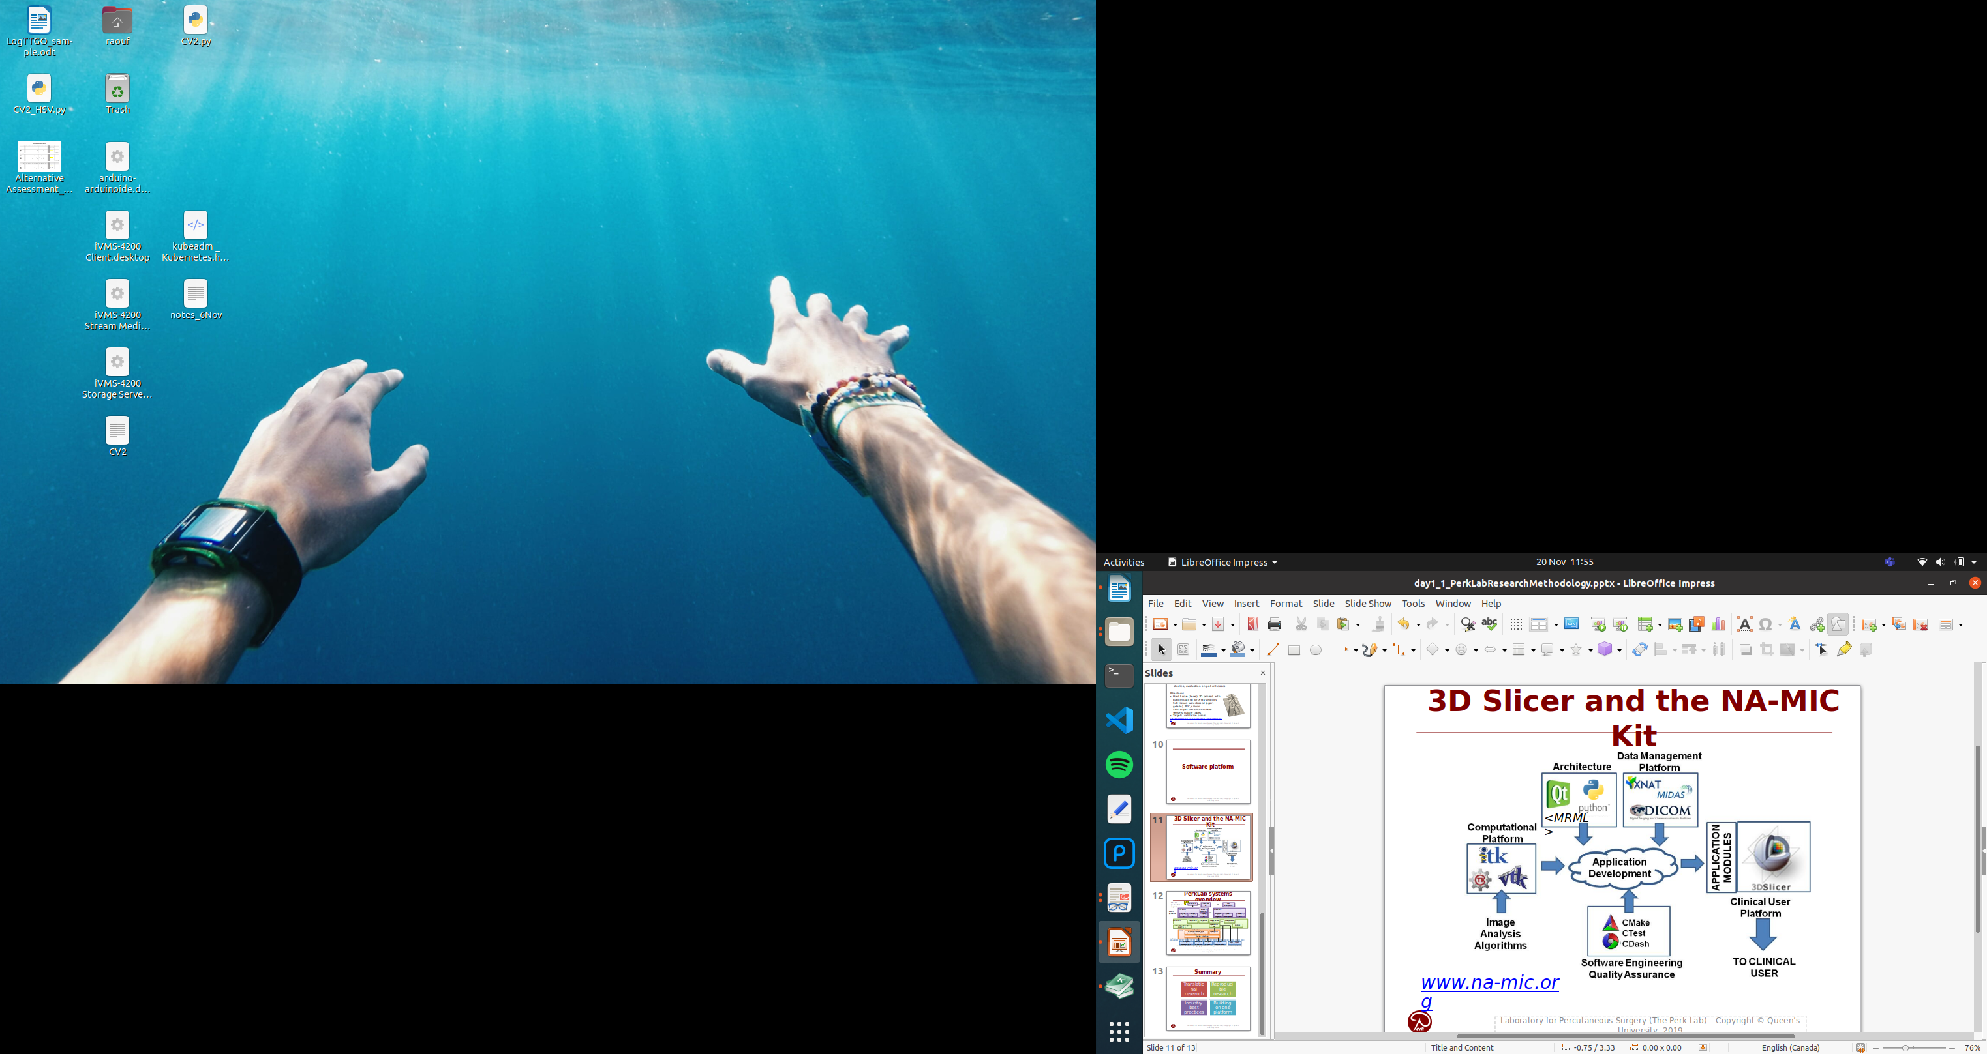Figure 2: 3D Slicer along with NA-MIC kit provides an all in one development platform for medical image processing projects. <https://www.na-mic.org/wiki/NA-MIC-Kit>

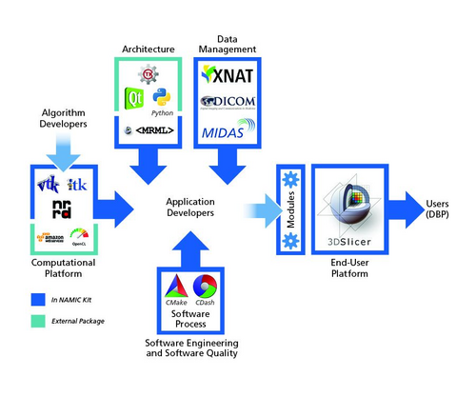

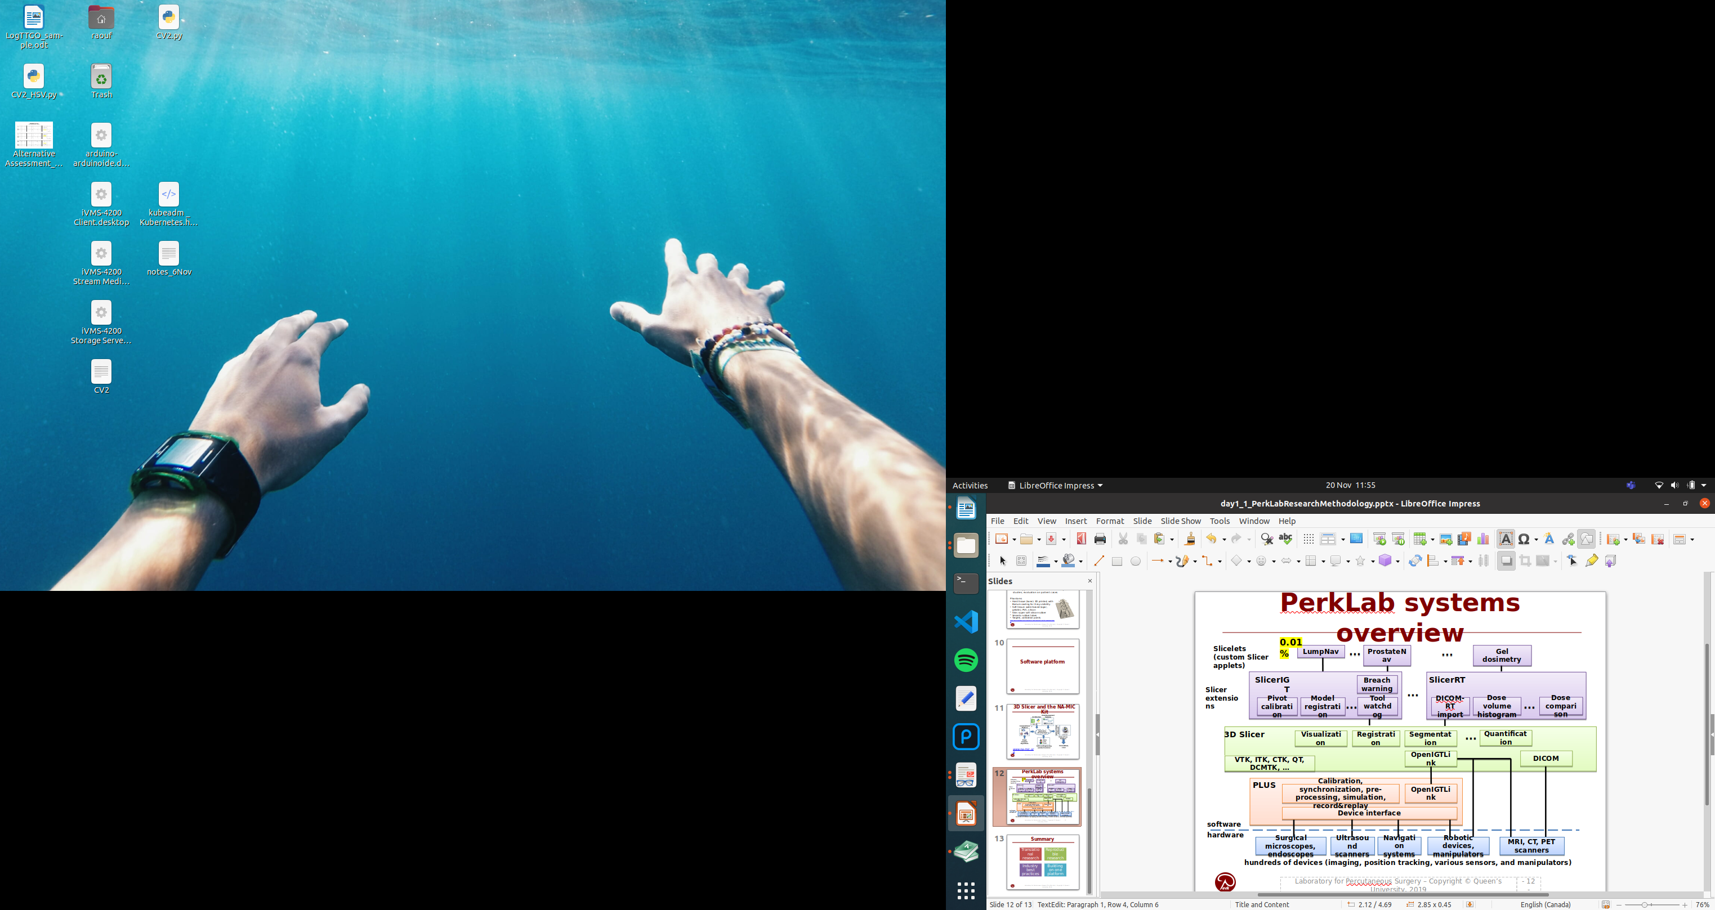Figure 3: 3D Slicer example use for registration and segmentation in Perklabs

References

1. <https://slicer.readthedocs.io/en/latest/developer_guide/mrml_overview.html>
2. <https://www.slicer.org/wiki/Documentation/Nightly/ScriptRepository>

#### ***Files/Objects/Protocols***

##### ***DICOM***

Digital Imaging and Communications in Medicine (DICOM) is the standard for the communication and management of medical imaging information and related data. DICOM is most commonly used for storing and transmitting medical images enabling the integration of medical imaging devices such as scanners, servers, workstations, printers, network hardware, and picture archiving and communication systems (PACS) from multiple manufacturers.

DICOM files can be exchanged between two entities that are capable of receiving image and patient data in DICOM format. The different devices come with DICOM Conformance Statements which state which DICOM classes they support.

The standard includes a file format definition and a network communications protocol that uses TCP/IP to communicate between systems.

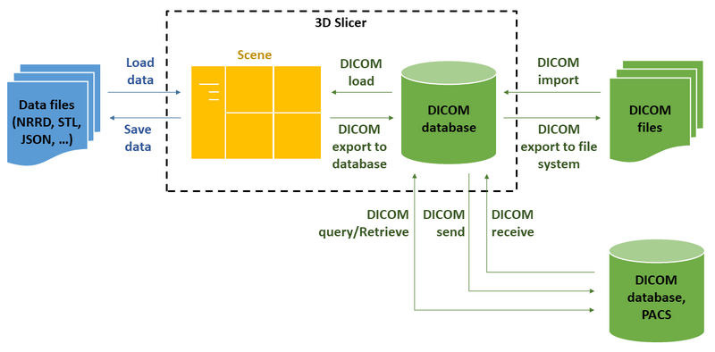Figure 4: Use of DICOM in 3D slicer which is software package for image analysis and scientific visualization.

DICOM file format organizes data following the hierarchy of

1. Patient … can have 1 or more
2. Study (single imaging exam encounter) … can have 1 or more
3. Series (single image acquisition, most often corresponding to a single image volume) … can have 1 or more
4. Instance (most often, each Series will contain multiple Instances, with each Instance corresponding to a single slice of the image)

As a result of imaging exam, imaging equipment generates DICOM files, where each file corresponds to one Instance, and is tagged with the information that allows to determine the Series, Study and Patient information to put it into the proper location in the hierarchy.

There is a variety of DICOM data objects defined by the standard. Most common object types are those that store the image volumes produced by the CT and MR scanners. Those objects most often will have multiple files (instances) for each series. Image processing tasks most often are concerned with analyzing the whole image volume, which most often corresponds to a single Series.

References and more information:

1. The DICOM Homepage: <http://dicom.nema.org/>
2. DICOM on wikipedia: <http://en.wikipedia.org/wiki/DICOM>
3. Clean and simple DICOM tag browser: [http://dicom.innolitics.com](http://dicom.innolitics.com/)
4. A useful tag lookup site: <http://dicomlookup.com/>

# Motivation (Link Background to problem statement)

Defining new problems, new constraints, new opportunities, new approaches

Motivation – why is it important to solve this problem? Any existing solutions? The pros and cons of these solutions. Why need further work?

Objective(s) – what do you want to achieve in your project?

# Research Methodology (Before this I need a problem and initial solution)

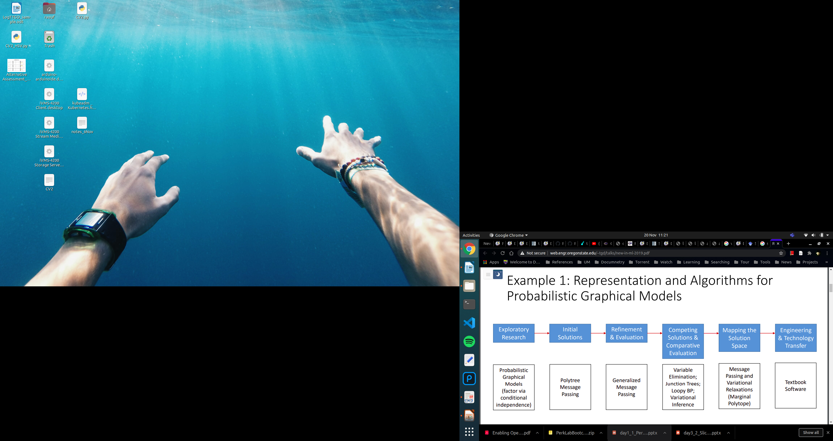

Research Methodology – how and what to do to achieve your objective(s)?

Your work done so far in the first semester (in detail) – report only your original work and results, not results from other papers. (Results and discussion)

## Reproducible Research

Scientific method: propose hypothesis, prove it by experiments. Here instead of hypothesis we have a design which is to solve an established problem.

First Problem is established, which is done by first evaluating purposes of ML in registration and then the gaps in the solutions already existing. The problem will focus to solve a gap.

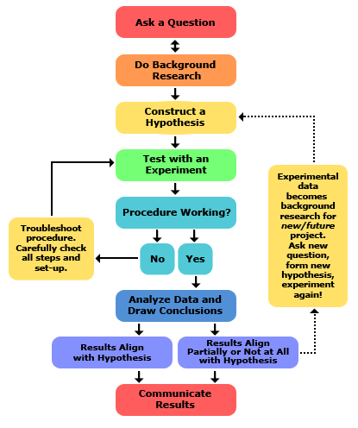

Scientific computation is becoming a core component of modern scientific inquiry. In the June 1996 issue of the flagship Journal of the American Statistical Association nine of twenty articles were computational, while in the June 2006 issue 33 of 35 were, and this trend is not limited to statistics. In numerous fields the increasing prevalence of data collection, computerized simulations, and deep data exploration indicate that scientific computation is becoming central to the scientific method.

Computational research is widely varied but components of the research that are necessary for others to understand and replicate the research, known as compendium, remain the same. They are:

1. **The Research Paper.**
   1. If included in a compiled format, such as pdf, then include the source files (TeX, Word, or WordPerfect files for example).
2. **The Data:**
   1. The data itself.
   2. Documentation completely describing the data so that a researcher in the same field could make use of it: Sources, components, and possibly interpretation.
   3. A description of how the data was brought into the form used in the research, including any selection and arrangement of the data, cleaning methods, or processing of variables in preparation for analysis.
   4. The code and instructions used to bring the data into the form used in the research.
   5. Documentation of any code used in this process.
3. **The Experiment:**
   1. The code and instructions used in the experiment, including all source code.
   2. Documentation of any code used, including pseudocode and algorithm descriptions.
   3. A clear listing of the parameters, settings, and conditions under which the code was used to achieve the results described in the paper, including software, platform, and computing environment.
   4. A clear description of the experimental methodology.

References

1. [Stodden, Victoria](kbibtex:filter:author=Stodden): [Enabling reproducible research: Open licensing for scientific innovation](kbibtex:filter:title=Enabling reproducible research: Open licensing for scientific innovation) , [*International Journal of Communications Law and Policy, Forthcoming*](kbibtex:filter:journal=International Journal of Communications Law and Policy, Forthcoming) , [2009](kbibtex:filter:year=2009)

## Translational Research

Translational research – a term often used interchangeably with translational medicine or translational science or bench to bedside – is an effort to build on basic scientific research to create new therapies,[1] medical procedures, or diagnostics. Basic biomedical research is based on studies of disease processes using, for example, cell cultures or animal models.[2] The adjective "translational" refers to the "translation" (the term derives from the Latin for "carrying over") of basic scientific findings in a laboratory setting into potential treatments for disease.

References

1. <https://en.wikipedia.org/wiki/Translational_research>

## Validation

Fidelity levels: Simulated < Synthetic phantoms < Animal tissue (butcher shop) < Cadaver < Patient

For validation we will do with simulations and synthetic phantoms

# Work Done So Far

1. Using 3D slicer for CIP
2. Select a ML model and do initial solutions

# Next Semester Plans

Planning for the second semester (Gantt Chart)

# References

References: include only relevant references, from reliable sources

# Appendices

## Proposal

|  |  |
| --- | --- |
| Supervisor | Mahmoud Mughavemi |
| Topic | Automatic registration for Image guided surgery for brain tumor resection |
| Title | Automated surface-based intraoperative registration for brain tumor resection using machine learning  Elements:   1. Automated surface Segmentation:   Obtaining  Using CNN model that can determine a given feature (e.g. contour of eye)→ outputs feature parameters   1. image processing:   Mapping patient face and creating a surface point cloud   1. Registration:   of the intraoperative and preoperative point clouds |
| Synopsis (Background, Problem statement, Objectives) | **Background**  With the progress in computer image vision technology, the mapping technique based on optical data has developed specially in the medical imaging field. One of the techniques used in mapping technology is use of stereoscopic cameras for surface-based registration, which is then visualized by overlaying it on 3D preoperative data (MRI, or CT) using either manual or automatic process. It is an interest to have a real-time automatic registration where traditional methods are inadequate.  **Problem Statement**  Traditional techniques make use of iterations and this manner is very slow where runtime in the tens of minutes are normal for common deformable image registration techniques even with an efficient implementation on the contemporary GPUs; while the practical use in clinical operations is real-time, and such a prolonged wasting time is not appreciated. This paper proposes utilizing deep learning to carry out the registration of face.  **Objectives**   1. Evaluate the need for machine learning registration over traditional registration of surfaces. 2. Evaluate a technique for segmentation of face from the rest of head model. 3. Use reliable NN model (CNN or SAE or GAN or RNN or DRL) for registration based on facial features 4. Demo Registration with control model (control is the unsegmented model)   (Extra)   1. Obtain 3D map of the face 2. Carryout registration based on extracted feature |
| Expected Outcomes | 1. Develop a model that determines the contour of the eye socket 2. Determine an evaluation metric and method for the registration 3. Carryout registration of (pre-segmented) face |
| Equipment Needed | Personal computer, suitable programming language software (3D slicer-free)  (Extra)  image acquisition devices . |

**Complex Engineering Attributes**

Assigned PLOs: PLO3 (WK5), PLO4 (WK8), PLO5 (WK6), PLO7 (WK7), PLO9, PLO11, PLO12

|  |  |  |  |
| --- | --- | --- | --- |
| Attribute | **Complex Engineering Problems have characteristic WP1 and some or all of WP2 to WP7:** | **PLOs addressed?** | **Comments from**  **FYP supervisor**  **(*give examples / clarifications* )** |
| Depth of Knowledge  Required | **WP1**: Cannot be resolved without in-depth engineering knowledge at the level of one or more of WK3, WK4, WK5, WK6 or WK8 which allows a fundamentals-based, first  principles analytical approach | PLO3, PLO4, PLO5, PLO7 | Required the fundamental knowledge on various field of image processing and artificial intelligence, such as template matching, image enhancement and filtering as well as machine learning. Student needs to basically apply fundamental knowledge in image processing and artificial intelligence to solve a given design problem. |
| Range of conflicting  requirements | **WP2**: Involve wide-ranging or conflicting technical, engineering and other issues | PLO3, PLO4 | During the design process, student needs to demonstrate limitations that they encounter during the process, e.g. lighting, image size and acquisition distance. |
| Depth of analysis  required | **WP3**: Have no obvious solution and require abstract thinking, originality in analysis to formulate suitable models | PLO7 | Student need to understand the problem and apply suitable solution which may have been applied in similar problem but in different application |
| Familiarity of issues | **WP4**: Involve infrequently encountered issues | PLO5 | The problem is unique thus requires  innovative thinking and adoption of many existing designs which are not directly applicable to the given problem |
| Extent of applicable  codes | **WP5**: Are outside problems encompassed by standards and codes of practice for professional engineering |  | Need to understand the strict medical imaging standards which can be encompassed for other sectors that use CV (e.g AV). |
| Extent of stakeholder  involvement and  conflicting requirements | **WP6**: Involve diverse groups of  stakeholders with widely varying needs |  | Many types of surgery and workflows associated with cranial surgery, which results in wide range of requirements |
| Interdependence | **WP 7**: Are high level problems including many component parts or sub-problems |  | Includes both software and hardware design and has sub problems within each. |